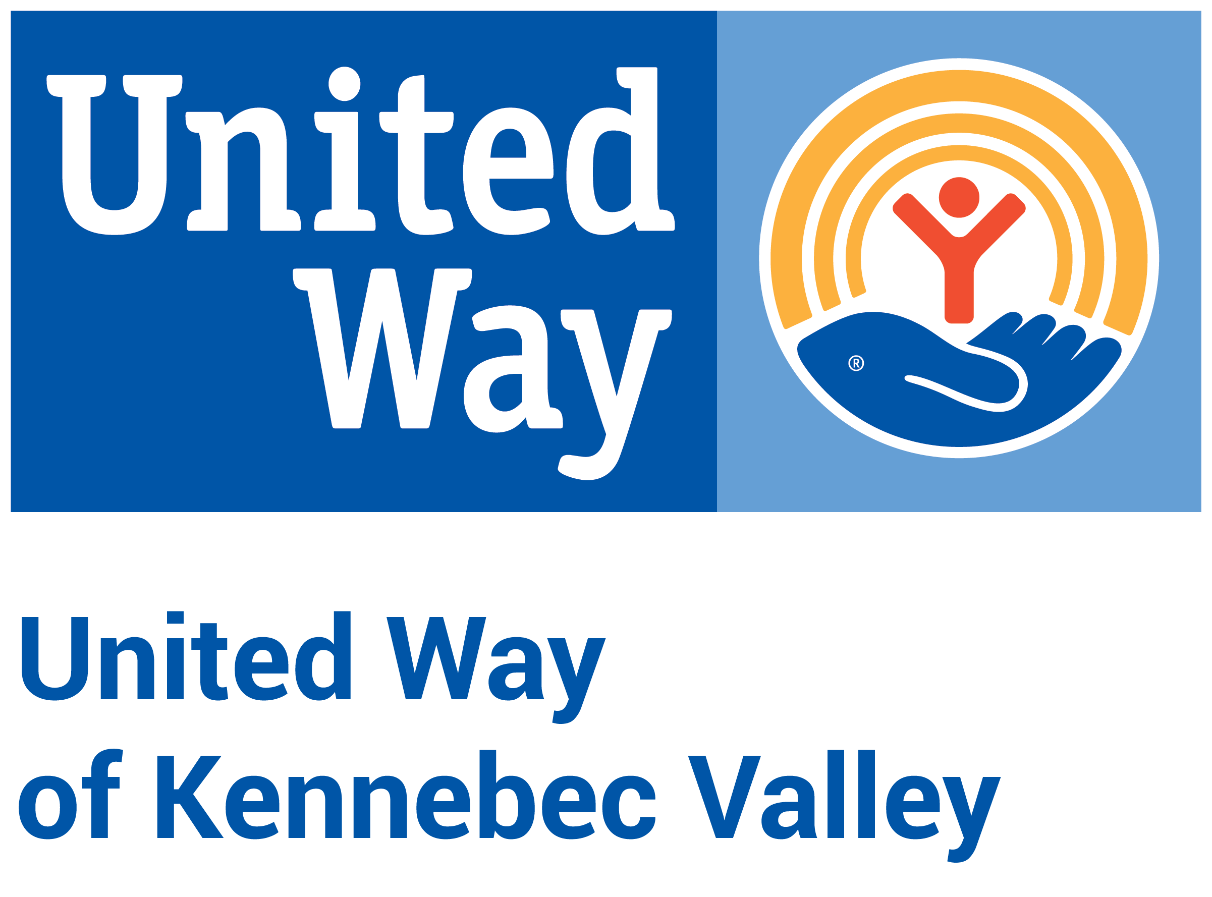

United Way of Kennebec Valley
2023 Community Investment Process – Letter of Intent Application
Funding Period: April 2023 – March 2025

Instructions

Use this template, if desired, to draft your Letter of Intent application before entering it into the e-CImpact grant management platform. You cannot submit your Letter of Intent as a Word document or PDF. Character counts include spaces.

United Way of Kennebec Valley (UWKV) is accepting Letter of Intent applications to address Impact2032 goals in health, education and financial stability in Kennebec County until November 22, 2022, at 4pm. Programs that are selected to move onto the second and final phase, the Application for Funding, will be notified by November 30, with the Application for Funding opening on December 1.

Note for Programs: This application is for two years of funding at the same amount. (Example: If you hope to receive $15,000 in 2023 and $15,000 in 2024, please apply for $15,000 total.)

Link to e-CImpact application: https://agency.e-cimpact.com/login.aspx?org=21010

Letter of Intent Application Questions

At different points in the application, you will be required to verify that you meet the Eligibility Requirements.

Organization & Contact Information

- Type of Applicant (choose one from a dropdown):
  - Nonprofit 501(c)(3)
  - Public school district
  - Municipal entity
  - Indian Tribal government

- Does the applicant have a fiscal agent?
  - Yes
    - If YES, the following questions will pop up:
      - Fiscal Agent Name (This is the holder of the 501(c)(3) Federal Tax ID or EIN):
      - Fiscal Agent Tax ID or EIN:
      - Fiscal Agent Address:
      - Fiscal Agent Website:
  - No

- Organization Name:

- Tax ID or EIN:

- Organization Website:

- Primary Address:

- Does your organization have a separate mailing address?

- CEO/Executive Director
  - Contact Information (name, title, phone, email)
- Board Chair
  - Contact Information (name, phone, email)
- Organization Mission (400 characters)

- Organization Description (750 characters)
- Describe how your organization strives to promote diversity, equity and inclusion among staff, board and volunteers. (750 characters)
- Does your organization have any legal processes pending? If so, please explain. (750 characters)

- Organizational Budget Information (Note: You do not need to submit any budget-related attachments for the LOI Application.)
  - Current Total Organizational Funding from UWKV (if you are not currently receiving any funding, enter 0): $
  - Organization’s Total Annual Budget: $

Note: After you have completed the Organization & Contact Information section, you will need to “Create a New Program and Assign it to this Form Packet.” This link is under the right-hand box titled “Assign Programs to this Letter of Intent.” If you would like to apply for funding for more than one program, you may add more than one program to your organization’s application.

Program Registration

- Program Name:

- Program Primary Contact (name, title, email, phone):

- Address (with option to copy Organization Primary Address):

- Email Address:

- Phone Number:

Note: Once you have submitted the Program Registration, two additional sections will show up in the box at the bottom of the page: Budget Narrative Information and Program Information.

Program Information

- Is this a new program or existing program at your organization? New/Existing
- Program Name for which funding is being requested: Auto-fills
- Program Description: Provide a brief description of the program for which you are requesting funding. If your program is funded, this description may be shared with other funded partners and in United Way marketing materials. (750 characters)
- What is the need for this program in the community? (1250 characters)

- Is this an application for a Collaboration? (A collaboration is a formal partnership among 2 or more organizations working together to provide a program.)
  - Yes
    - If YES, includes these questions:
      - Collaboration Name:
      - Collaboration Website, if available:
      - Number and list of organizational partners:
      - Collaboration Description (750 characters):
  - No

Strategies and Measures (within Program Information section)

Please review the Impact2032 Vision framework in detail before completing the following section.

- How many unique individuals (unduplicated) do you anticipate your program will serve with UWKV funding? Reminder: Applicants must use funding to serve Kennebec County exclusively. This number should include only the number of people that UWKV funding specifically would help, which may differ from total number of people served through the program.
  - Insert number
- Please select which Impact2032 Vision Statement your program will best contribute to achieving, based on each vision’s measurements and strategies. (Choose which one best fits.)

  - Vision for Health - Children and adults in Kennebec County will have opportunities to engage in healthy behaviors and leverage prevention and wellness services.
  - Vision for Education - Children and families in Kennebec County will have access to quality early learning experiences prior to kindergarten.
  - Vision for Financial Stability - Adults and families in Kennebec County will have employment, income and resources to achieve ﬁnancial stability.

- Describe how you plan to align with Impact2032 through this program. (750 characters) Note: If your Letter of Intent is approved, your program will be required to provide more detailed information within the full Application for Funding. For the full Application, this detailed information will include how the program supports 1-3 outcomes, 1-2 strategies per selected outcome (from the Key Strategies list or of your own choosing), and 1-2 measures for each strategy (of your own design). For this question in the LOI, each program only needs to provide an overview of Impact2032 alignment under your selected Vision Statement.

Budget Narrative Information

- Current Funding from UWKV for this Program (if you are not currently receiving any funding, enter 0): $
- Funding Amount Requested for the Program (Reminder: Program may only request between $5,000 and $50,000): $
- Total Program Budget (Reminder: Your funding request cannot exceed 35% of the program/project budget): $
- In a few sentences, please describe how you plan to use the funds being requested from UWKV (not the individual budget line amounts). No UWKV budget form is necessary for the LOI stage of the application. (750 characters)

