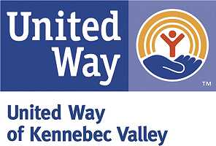

Funding Application Completion Check List
- One original and 15 copies of the application ____
- One copy of your most recent IRS Form 990 ____
- One copy of the United Way agreement (annually) ____
- Agency updates, such as Board Roster ____
- Proof of Director’s and Officer’s Liability Insurance ____
- Beneficiary Table ____
- Current budget information ____
- Review all sections of application for completeness ____
- Arrange to have person with financial knowledge and a consumer at presentation before Allocations committee ____

