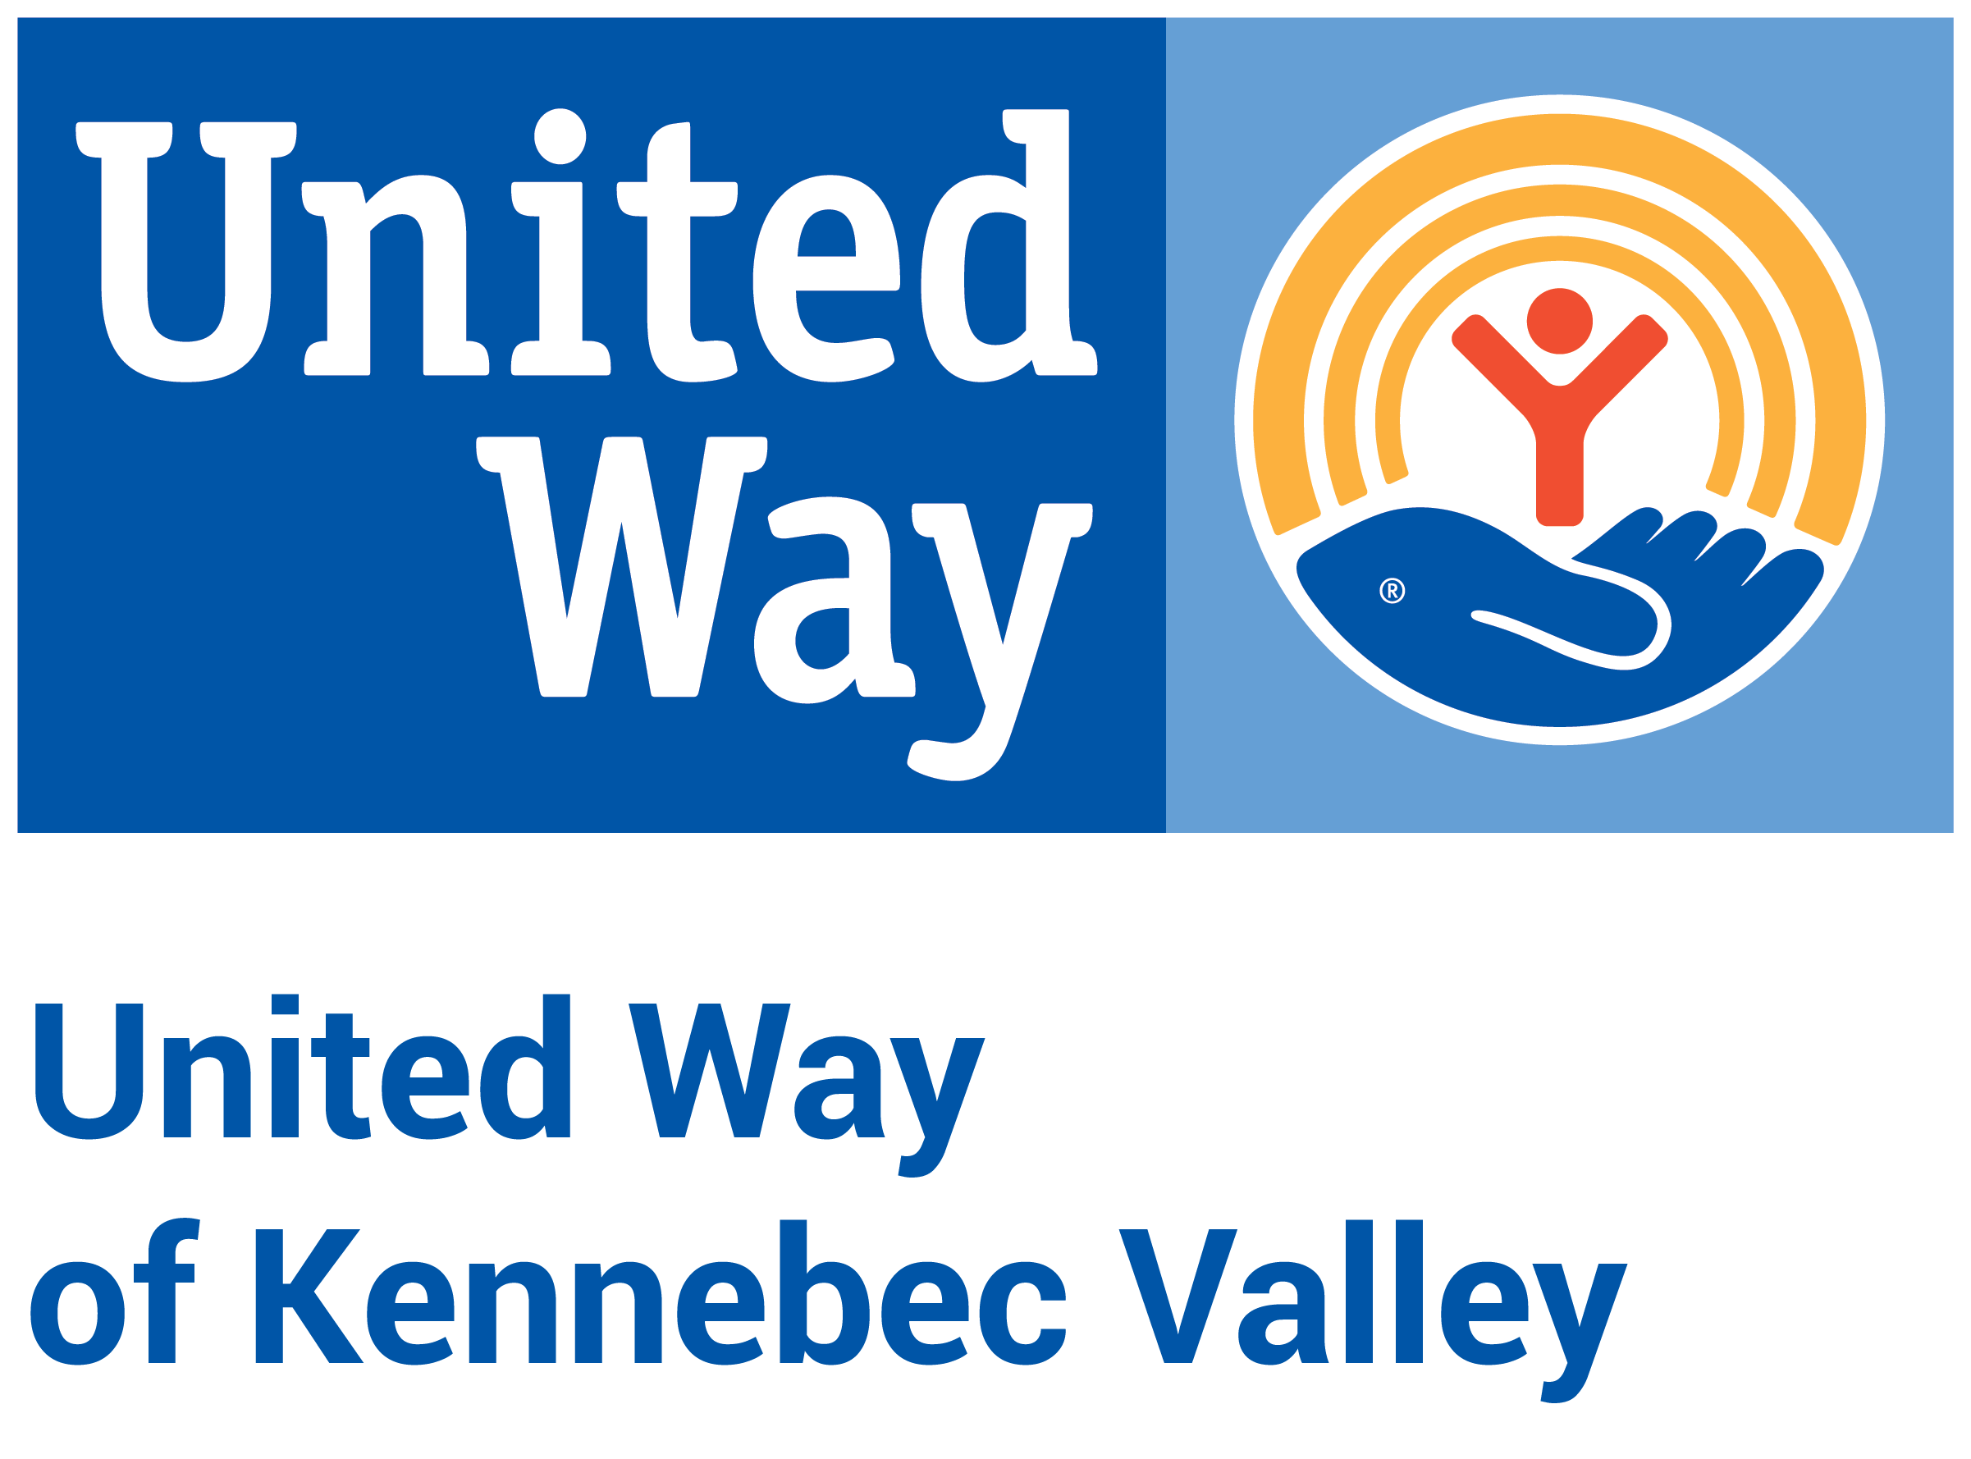

United Way of Kennebec Valley
2025 Community Investment Process – Application for Funding
Funding Period: May 2025 – March 2027
Due Date for Application: January 31, 2025, at 4:00pm

Instructions

This Application for Funding will be live in e-CImpact on December 2, 2024. Use this template, if desired, to draft your Application before entering it into the e-CImpact grant management platform. You cannot submit your Application as a Word document or PDF.

“Comments” on this document have been intentionally included to help you understand our expectations and delineate which questions are required for each funding stream.

We include character counts to help you understand the length of response we’re looking for; character counts include spaces. If you are applying for the Basic Needs Grant, we don’t expect the same level of detail and length of response as we do for the other two applications.

Our expectation is that programs will expend funds during the Funding Period (May 2025-March 2026 and April 2026-March 2027) and report data back based on that Funding Period.

Programs with successful Letters of Intent were notified via email on or around November 27, 2024. Successful programs will move onto the second and final phase, the Application for Funding, which will open on December 2, 2024, and be due on January 31, 2025, at 4:00pm.

Note for Programs: This application is for two years of funding at the same amount. (Example: If you hope to receive $15,000 in 2025 and $15,000 in 2026, please apply for $15,000 total. Do not apply for $30,000.)

Link to e-CImpact application: https://agency.e-cimpact.com/login.aspx?org=21010

Application Questions

Note: Many responses will auto-fill based on your responses in the Letter of Intent.

Organization & Contact Information

No new responses required in this section. All questions have been auto-filled from Letter of Intent.

Organization Attachments

Upload the following attachments. All documents may be in your own format unless otherwise noted.

- 501(c)(3) letter of determination
- Organizational chart
- Board member list (include names, positions and affiliations for each board member)
- Organization budget
- Required financial documents (most recent year only)
  - Organizations with revenue more than $2,000,000 are required to submit an audit.
  - Organizations with revenue more than $1,000,000 but less than $1,999,999 are required to submit an audit or Review of Financial Statement.
  - Organizations with revenues in the preceding year of less than $1,000,000 are required to submit IRS Form 990.
- IRS Form 990 (If an organization has not yet filed a Form 990 due to a recent incorporation date or is not required to file a Form 990 for various reasons, please submit a brief statement in a Word document explaining the situation. If your organization already uploaded its 990 in the "Required financial documents" field, please upload your 990 again to fulfill this required field.)
- Anti-Terrorism Compliance Form (download UWKV’s form, sign, and upload)
- UWKV’s Diversity, Equity and Inclusion Statement Acknowledgement (download UWKV’s form, sign, and upload)
- Fiscal agent MOU (only if applicable)

Program Information
- Which of the three funding streams within the Community Investment Process is your program applying for:
  - Strategic Investment Grant
  - Basic Needs Grant
  - Innovation Grant
auto-fills, uneditable
- Program Name for which funding is being requested: auto-fills, uneditable
- Program Description: Provide a brief description of the program for which you are requesting funding. (750 characters) auto-fills, editable
- What is the need for this program in the community? (1250 characters)
- How is your proposed program/project innovative for our community? (1250 characters) auto-fills, editable

- Provide a summary of the best evidence available that supports your approach. Please include evidence-based approaches and/or data from credible sources wherever possible. (1250 characters)

- How do you collaborate with outside stakeholders and partners to leverage resources in your program? If appropriate, how do you ensure your program isn’t unnecessarily duplicating services offered elsewhere in Kennebec County? (1250 characters)

- Provide current and most relevant internal data for your program. (Examples: 75% of participants applied for full scholarships, and 55% received them; We served 25,000 meals, which was an increase of 5% over last year; The program has increased volunteers from 25 to 35 since last year.) (1250 characters)

- Provide a success story from this program. (Note: This story may be used in UWKV marketing materials moving forward. Please anonymize names if needed.) (2000 characters)

- What are the risks associated with this program/project, and how will you mitigate those risks?

- Is this an application for a Collaboration? (A collaboration is a formal partnership among 2 or more organizations working together to provide a program. If you list a Collaboration organization, you must provide an MOU among your Program Attachments. In addition, all Collaboration organizations must have an Impact2032 Statement of Endorsement on file at UWKV.)
  - Yes
    - If YES, includes these questions:
      - Collaboration Name:
      - Collaboration Website, if available:
      - Number and list of organizational partners:
      - Collaboration Description (750 characters):
  - No
- Describe how this particular program considers diversity, equity and inclusion. What specific actions have you taken to identify and address disparities and promote DEI in program delivery? (1250 characters)

Strategies and Measures Preview (within Program Information section)

Please review the Impact2032 Vision framework in detail before completing the following section. While the mission of your organization and/or purpose of your program may not be directly related to the goals of Impact2032, please consider the vision statements and corresponding outcomes, strategies, and measures in the design and delivery of your program in order to further the progress of Impact2032.
- Please select which Impact2032 Vision Statement your program will best contribute to achieving, based on each vision’s desired outcomes, measurements and strategies. (Choose which one best fits.) autofills, uneditable
  - Vision for Health - Children and adults in Kennebec County will have opportunities to engage in healthy behaviors and leverage prevention and wellness services.
  - Vision for Education - Children and families in Kennebec County will have access to quality early learning experiences prior to kindergarten.
  - Vision for Financial Stability - Adults and families in Kennebec County will have employment, income and resources to achieve ﬁnancial stability.

- Provide an overview of how you plan to align with Impact2032 through this program. How will you consider your chosen vision statement in the design and delivery of your program in order to further the progress of Impact2032? (750 characters) auto-fills, editable

Strategies & Measures
Prior to completing this embedded form, select a Vision Area on the Program Information form.
Select 1-3 Impact2032 Outcomes underneath your selected Vision that best align with your program. Note: Your score is not improved by choosing more than one.
Once an Outcome is selected, choose 1-2 Key Strategies for each Outcome that you will employ to achieve the Outcome. Key Strategies may be from the UWKV-provided list for each Outcome (see: Impact2032 Framework) or of your own choosing. We define “key strategy” as a plan of action designed to achieve the Outcome. Note: Your score is not improved by choosing more than one.
For each Key Strategy that you provide, please select 1-2 Measures that you will use to measure progress of your Key Strategy. Because your organization and/or program already has a specific mission and/or purpose, you likely have developed your own measures to determine the success of your program, which should be included in your response to the following question under program description if this is an existing program: “Provide current and most relevant internal data for your program.”
In this section, please choose a measure to assess your efforts around considering Impact2032 in the design and delivery of your program. You are unable to provide your own measures in this section of the application, as the goal of Impact2032 is to achieve collective impact. Note: Your score is not improved by choosing more than one.

Vision Area:
- Prior to completing this embedded form, select a Vision Area on the Program Information form.

Desired Outcome:
- Select 1-3 Desired Outcomes underneath your selected Vision Area that your program will best contribute to achieving.
- Note: Your score is not improved by choosing more than one.

Key Strategy(ies):
- Once a Desired Outcome is selected, choose 1-2 Key Strategies for each Desired Outcome that you will employ to achieve the Desired Outcome.
- Key Strategies may be from the UWKV-provided list for each Desired Outcome (see: Impact2032 Framework) or of your own choosing.
- We define “key strategy” as a plan of action designed to achieve the Desired Outcome.
- Note: Your score is not improved by choosing more than one.

Measures:
- For each Key Strategy that you provide, please select 1-2 Measures that you will use to gauge progress through and/or as a result of the Key Strategies implemented in your program.
  - Because your organization and/or program already has a specific mission and/or purpose, you likely have developed your own measures to determine the success of your program, which should be included in your response to the following question under program description if this is an existing program: “Provide current and most relevant internal data for your program.”
  - In this section, please choose a measure to assess your efforts around considering Impact2032 in the design and delivery of your program.
- You are unable to provide your own measures in this section of the application, as the goal of Impact2032 is to achieve collective impact.
- You will be reporting on the selected 1-2 Measures as part of your annual reports, so please make sure to continue or implement a system to collect the information for the grant funding period.
- Note: Your score is not improved by choosing more than one.
MEASURES TO CHOOSE FROM:
Vision for Health

Children and adults will have resources to participate in behaviors that promote health and wellness.

- Percentage/number of program participant meals/snacks that include a fruit and/or vegetable.
- Number of organized physical activity opportunities for program participants.
- Percentage/number of program participants who leveraged expanded access to tobacco cessation resources.
- Percentage of time program participants spend outdoors during program hours.
- Number of intentional social engagement opportunities for program participants.
- Percentage/number of program participants who leveraged expanded access to resources that support other behavior changes to promote health and wellness.
- Percentage/number of program participants who reported that they changed a behavior to promote health and wellness.

Children and adults will have access to prevention and wellness services for improved health outcomes.

- Percentage/number of program participants who practiced coping and critical thinking skills.
- Percentage/number of program participants who leveraged expanded access to physical healthcare.
- Percentage/number of program participants who leveraged expanded access to behavioral healthcare.
- Percentage/number of program participants who leveraged expanded access to substance use and/or harm reduction services.
- Percentage/number of program participants who leveraged expanded access to dental care.
- Percentage/number of program participants who leveraged expanded access to chronic disease prevention and/or management.
- Percentage/number of program participants who developed at least one new social connection (positive relationships with family, friends, neighbors, and others in the community).
- Percentage/number of program participants who established at least one new concrete support in a time of need (access to basic needs and services, such as food, clothing, shelter, health care, and financial security).
- Percentage/number of program participants who developed natural and/or concrete supports.

Children and adults will have the ability to achieve optimum health regardless of social and economic barriers.

- Percentage/number of program participants who leveraged expanded access to resources for food insecurity to achieve optimum health.
- Percentage/number of program participants who newly connected to health care coverage to achieve optimum health.
- Percentage/number of program participants who leveraged expanded access to resources for literacy to achieve optimum health.
- Percentage/number of program participants who leveraged expanded access to resources for English language learners to achieve optimum health.
- Percentage/number of program participants who leveraged expanded access to resources for transportation to achieve optimum health.
- Percentage/number of program participants who leveraged expanded access to resources for domestic violence to achieve optimum health.
- Percentage/number of program participants who leveraged expanded access to resources for basic hygiene to achieve optimum health.

Vision for Education

Children and families will have opportunities to develop literacy and language skills to support school readiness.

- Percentage/number of program participants who increased their average reading time.
- Percentage/number of families who engaged in reading opportunities with program participants.
- Percentage/number of program participants who leveraged expanded access to resources to increase language and/or reading skills.
- Percentage/number of program participants who leveraged expanded access to early education programming.
- Percentage/number of program participants who leveraged expanded access to resources to support their participation in early education programming.
- Percentage/number of program employees who report that they changed a practice or acted differently as a result of a professional development opportunity related to literacy and language.
- Percentage/number of program participants or employees who leveraged expanded access to free or low-cost professional development opportunities to improve instructional practices and early childhood teaching and learning.
- Percentage/number of program participants or employees who leveraged expanded access to financial incentives to start and/or further education in early childhood education.

Children and families will have resources needed to promote their social and emotional development.

- Percentage/number of program participants who leveraged expanded access to services to improve resiliency.
- Percentage/number of program participants who leveraged expanded access to resources to support social and emotional functioning.
- Percentage of program participant parents/families who reported that they changed a practice or behavior to support their child’s social and emotional functioning.
- Percentage/number of program employees who report that they changed a practice or acted differently as a result of a professional development opportunity related to social and emotional development.
- Average number of other social service providers involved with program participant and/or parents/families.
- Percentage/number of program participants who leveraged expanded access to extended school programming (before/after/weekend/summer).
- Percentage/number of program participants who leveraged expanded access to resources to support their participation in extended school programming (before/after/weekend/summer).

Children and families will have basic health and safety needs met to be ready for learning.

- Percentage/number of program participants who leveraged expanded access to resources related to healthy pregnancy.
- Percentage/number of program participants who leveraged expanded access to an appropriate nutrition program, such as TANF, SNAP, WIC, food banks, and/or farmer’s market.
- Percentage/number of program participants who leveraged expanded access to free, high-quality, nutritious meals/snacks.
- Percentage/number of parents/families who participated in conversations about child abuse and neglect.
- Percentage/number of program employees who are mandated reporters and receive associated annual training.
- Percentage of program participants screened for developmental concerns.

Vision for Financial Stability

Adults and/or families will have a degree or credential of value to become employable.

- Percentage/number of program participants who earned their high school diploma.
- Percentage/number of program participants who earned a degree and/or credential of value that provides them with certification required for a position.
- Percentage/number of program participants who leveraged expanded access to funding to support their education and/or career goals.
- Percentage/number of program participants who leveraged expanded access to support services to earn their degree and/or credential of value.
- Percentage/number of program participants who increased their wages and/or access to benefits.

Adults and/or families will have the income to be financially stable.

- Percentage/number of program participants who are currently employed.
- Percentage/number of program participants who have maintained employment for at least three months.
- Percentage/number of program participants who leveraged expanded access to support services to remain employed.
- Percentage/number of program participants with more than one source of income.
- Percentage/number of program participants who leveraged expanded access to support to supplement income.
- Percentage of program participants who leveraged expanded access to safe, stable, and/or subsidized housing.
- Percentage/number of program participants who have maintained safe, stable, and/or subsidized housing for at least three months.

Adults and/or families have the ability to afford and access services to be financially independent.

- Percentage/number of program participants who leveraged expanded access to resources about landlord/tenant behavior and relationships.
- Percentage/number of program participants who leveraged expanded access to transportation.
- Percentage/number of program participants who leveraged expanded access to funding to support child care expenses.
- Percentage/number of program participants who leveraged expanded access to training or programs that teach job preparation skills.
- Percentage/number of program participants who leveraged expanded access to resources around language and/or soft skills to become employable.
- Percentage/number of program participants who leveraged expanded access to hygiene and/or clothing resources to become employable.
- Percentage/number of program participants who leveraged expanded access to financial literacy education and/or financial coaching.

Implementation Plan

- Please provide a list of the expected implementation milestones based on the following time periods. Please consider key activities, projected dates of completion, and outputs/outcomes. Note: You will be required to submit two grant reports to UWKV (due March 2026 and March 2027).

Period 1: May 2025 – September 2025 (750 characters)

Period 2: October 2025 – March 2026 (750 characters)

Period 3: April 2026 – September 2026 (750 characters)

Period 4: October 2026 – March 2027 (750 characters)

Demographics Served

Through the Demographics Served section, UWKV aims to understand the reach of UW funding and better position UWKV to secure community support. We recognize that to understand who you’re missing in your program service delivery efforts, you first have to understand who you’re serving.

- How many unique individuals (unduplicated) do you anticipate your program will serve with UWKV funding? Reminder: Applicants must use funding to serve residents of Kennebec County or those who are unhoused exclusively. This number should include only the number of people that UWKV funding specifically would help, which may differ from total number of people served through the program.

- Describe the program’s target population and the demographics it serves (such as different races/ethnicities, disability/ability status). Explain how you identify community need for this population and any specific outreach that the organization does to reach your target population. (1250 characters)

- Does this program have eligibility requirements for accessing United Way-funded services? If so, please provide a brief description.

- How many volunteers, if any, donated time to this program in the most recent year?

- Please indicate which demographics data your program collects. Please only select demographics information on which you will be able to report data back to UWKV. If you cannot report data, please do not select the category.

      - The program anticipates collecting data on household income (https://aspe.hhs.gov/topics/poverty-economic-mobility/poverty-guidelines) – Yes/No
If yes, the program anticipates serving people with the following household income:
      - Above Low-Income (185% of the Federal Poverty Level)
      - Below Federal Poverty Level
      - Federal Poverty Level
      - Income Unknown
      - Low-Income (Between the Federal Poverty Level and 185% of Federal Poverty Level)

      - The program anticipates collecting data on employment status – Yes/No
If yes, the program anticipates serving people with the following employment status:
      - Employed, full-time
      - Employed, part-time
      - Not able to work
      - Not employed, looking for work
      - Not employed, not looking for work
      - Retired
      - The program anticipates collecting data on housing status – Yes/No
If yes, the program anticipates serving people with the following housing status:
      - I do not have stable housing
      - I have stable housing
      - The program anticipates collecting data on gender identity – Yes/No
If yes, the program anticipates serving people who identify as:
      - Females
      - Gender non-conforming
      - Males
      - Transgender
      - The program anticipates collecting data on age – Yes/No
If yes, the program anticipates serving people in the following age groups:
      - 0-9 years
      - 10-14 years
      - 15-20 years
      - 21-35 years
      - 36-50 years
      - 51-65 years
      - 66-80 years
      - 81+ years

      - The program anticipates collecting data on race/ethnicity – Yes/No
If yes, the program anticipates serving people of the following race/ethnicity:
      - Asian American, Pacific Islander
      - Black, African American
      - Latinx/Hispanic
      - Middle Eastern, North African, Arab
      - Multiracial
      - Native American
      - White, European American
      - Other, please specify: _______________
      - The program anticipates collecting data on geographic area served (when reporting, you will be expected to report on number served from each town selected) – Yes/No
The program anticipates serving people who live in the following towns:
All of the following
Albion
Augusta
Belgrade
Benton
Chelsea
China
Clinton
Farmingdale
Fayette
Gardiner
Hallowell
Litchfield
Manchester
Monmouth
Mt. Vernon
Oakland
Pittston
Randolph
Readfield
Rome
Sidney
Vassalboro
Vienna
Waterville
Wayne
West Gardiner
Windsor
Winslow
Winthrop
No assigned town (e.g., homeless population)

      - The program anticipates collecting data on sexual orientation – Yes/No
If yes, the program anticipates serving people with the following sexual orientation:
      - Asexual
      - Bisexual
      - Gay
      - Heterosexual
      - Lesbian
      - Queer

      - The program anticipates collecting data on disability/ability status – Yes/No
If yes, the program anticipates serving people with the following disability/ability statuses:
      - Learning disability
      - Long-term medical illness
      - Mental health disorder
      - Mobility impairment
      - Sensory impairment
      - Temporary impairment due to illness or injury
      - The program anticipates collecting data on the primary language spoken at home – Yes/No
If yes, please list the languages spoken at home that you anticipate: ______________
      - The program anticipates collecting data on whether a person can speak, write, and/or read English – Yes/No

      - The program anticipates collecting data on veteran status – Yes/No
If yes, the program anticipates serving people with the following veteran status:
      - Not a United States Armed Forces Veteran
      - United States Armed Forces Veteran
      - Is there any other demographics information that your program collects that you want to make UWKV aware of? (200 characters)

Budget Narrative Information
- Funding Amount Requested for the Program (Reminder: Each grant type has its own funding ranges; please answer accordingly): $
autofills, uneditable
- Total Program Budget (Reminder: Your funding request cannot exceed 35% of the program/project budget.): $
- In a few sentences, please describe how you plan to use the funds being requested from UWKV. (Note: Do not include individual budget line amounts.) (Note: We've included your response to this question from the LOI as a reminder of your plan. It is read-only and cannot be edited. We expect the following question about the budget narrative to provide more details.) (750 characters)
autofills, uneditable

- In addition to completing and submitting the Program Budget Template (next section), provide an explanation/narrative of your program/project budget. Include how UWKV funding fits with any other funding received for this program, including funding received through the American Rescue Plan Act. (750 characters)
- What is your sustainability plan for funding the program? (750 characters)
- Does your organization have an endowment or similar investment account as a source of ongoing financial support?
  - Yes/No

Program Budget Template

Note: This is a template that you will complete within the form itself. Screenshots are included below for reference.

Please complete this budget template for the program for which you are requesting funds, NOT for the entire organization budget.
Reminders: 1) Funding must support a specific program or project, not general operations. 2) The funding request must not exceed 35% of the program/project budget. 3) Program’s administrative (indirect) expenses may not exceed 20%.

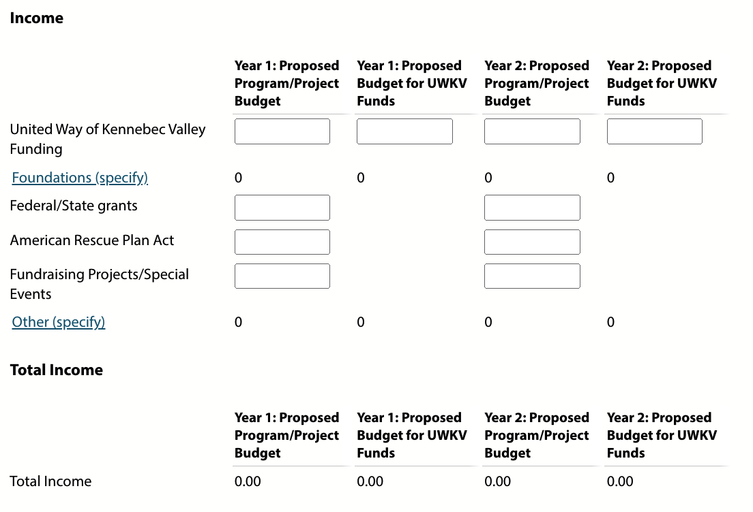

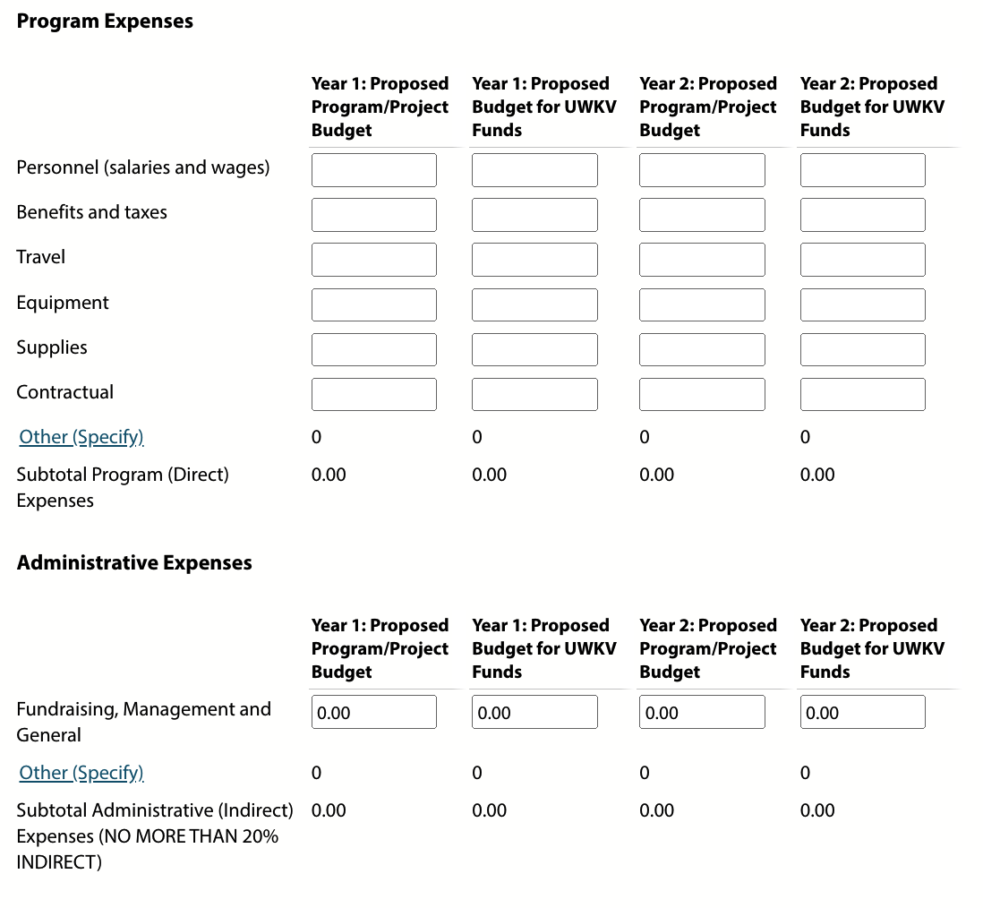

Program Attachments
Upload the following attachment(s).
- Partner Program Agreement (download UWKV’s form, sign, and upload)
- Formal Collaboration MOUs (if applicable; required if you list any formal collaborations; use own format)

