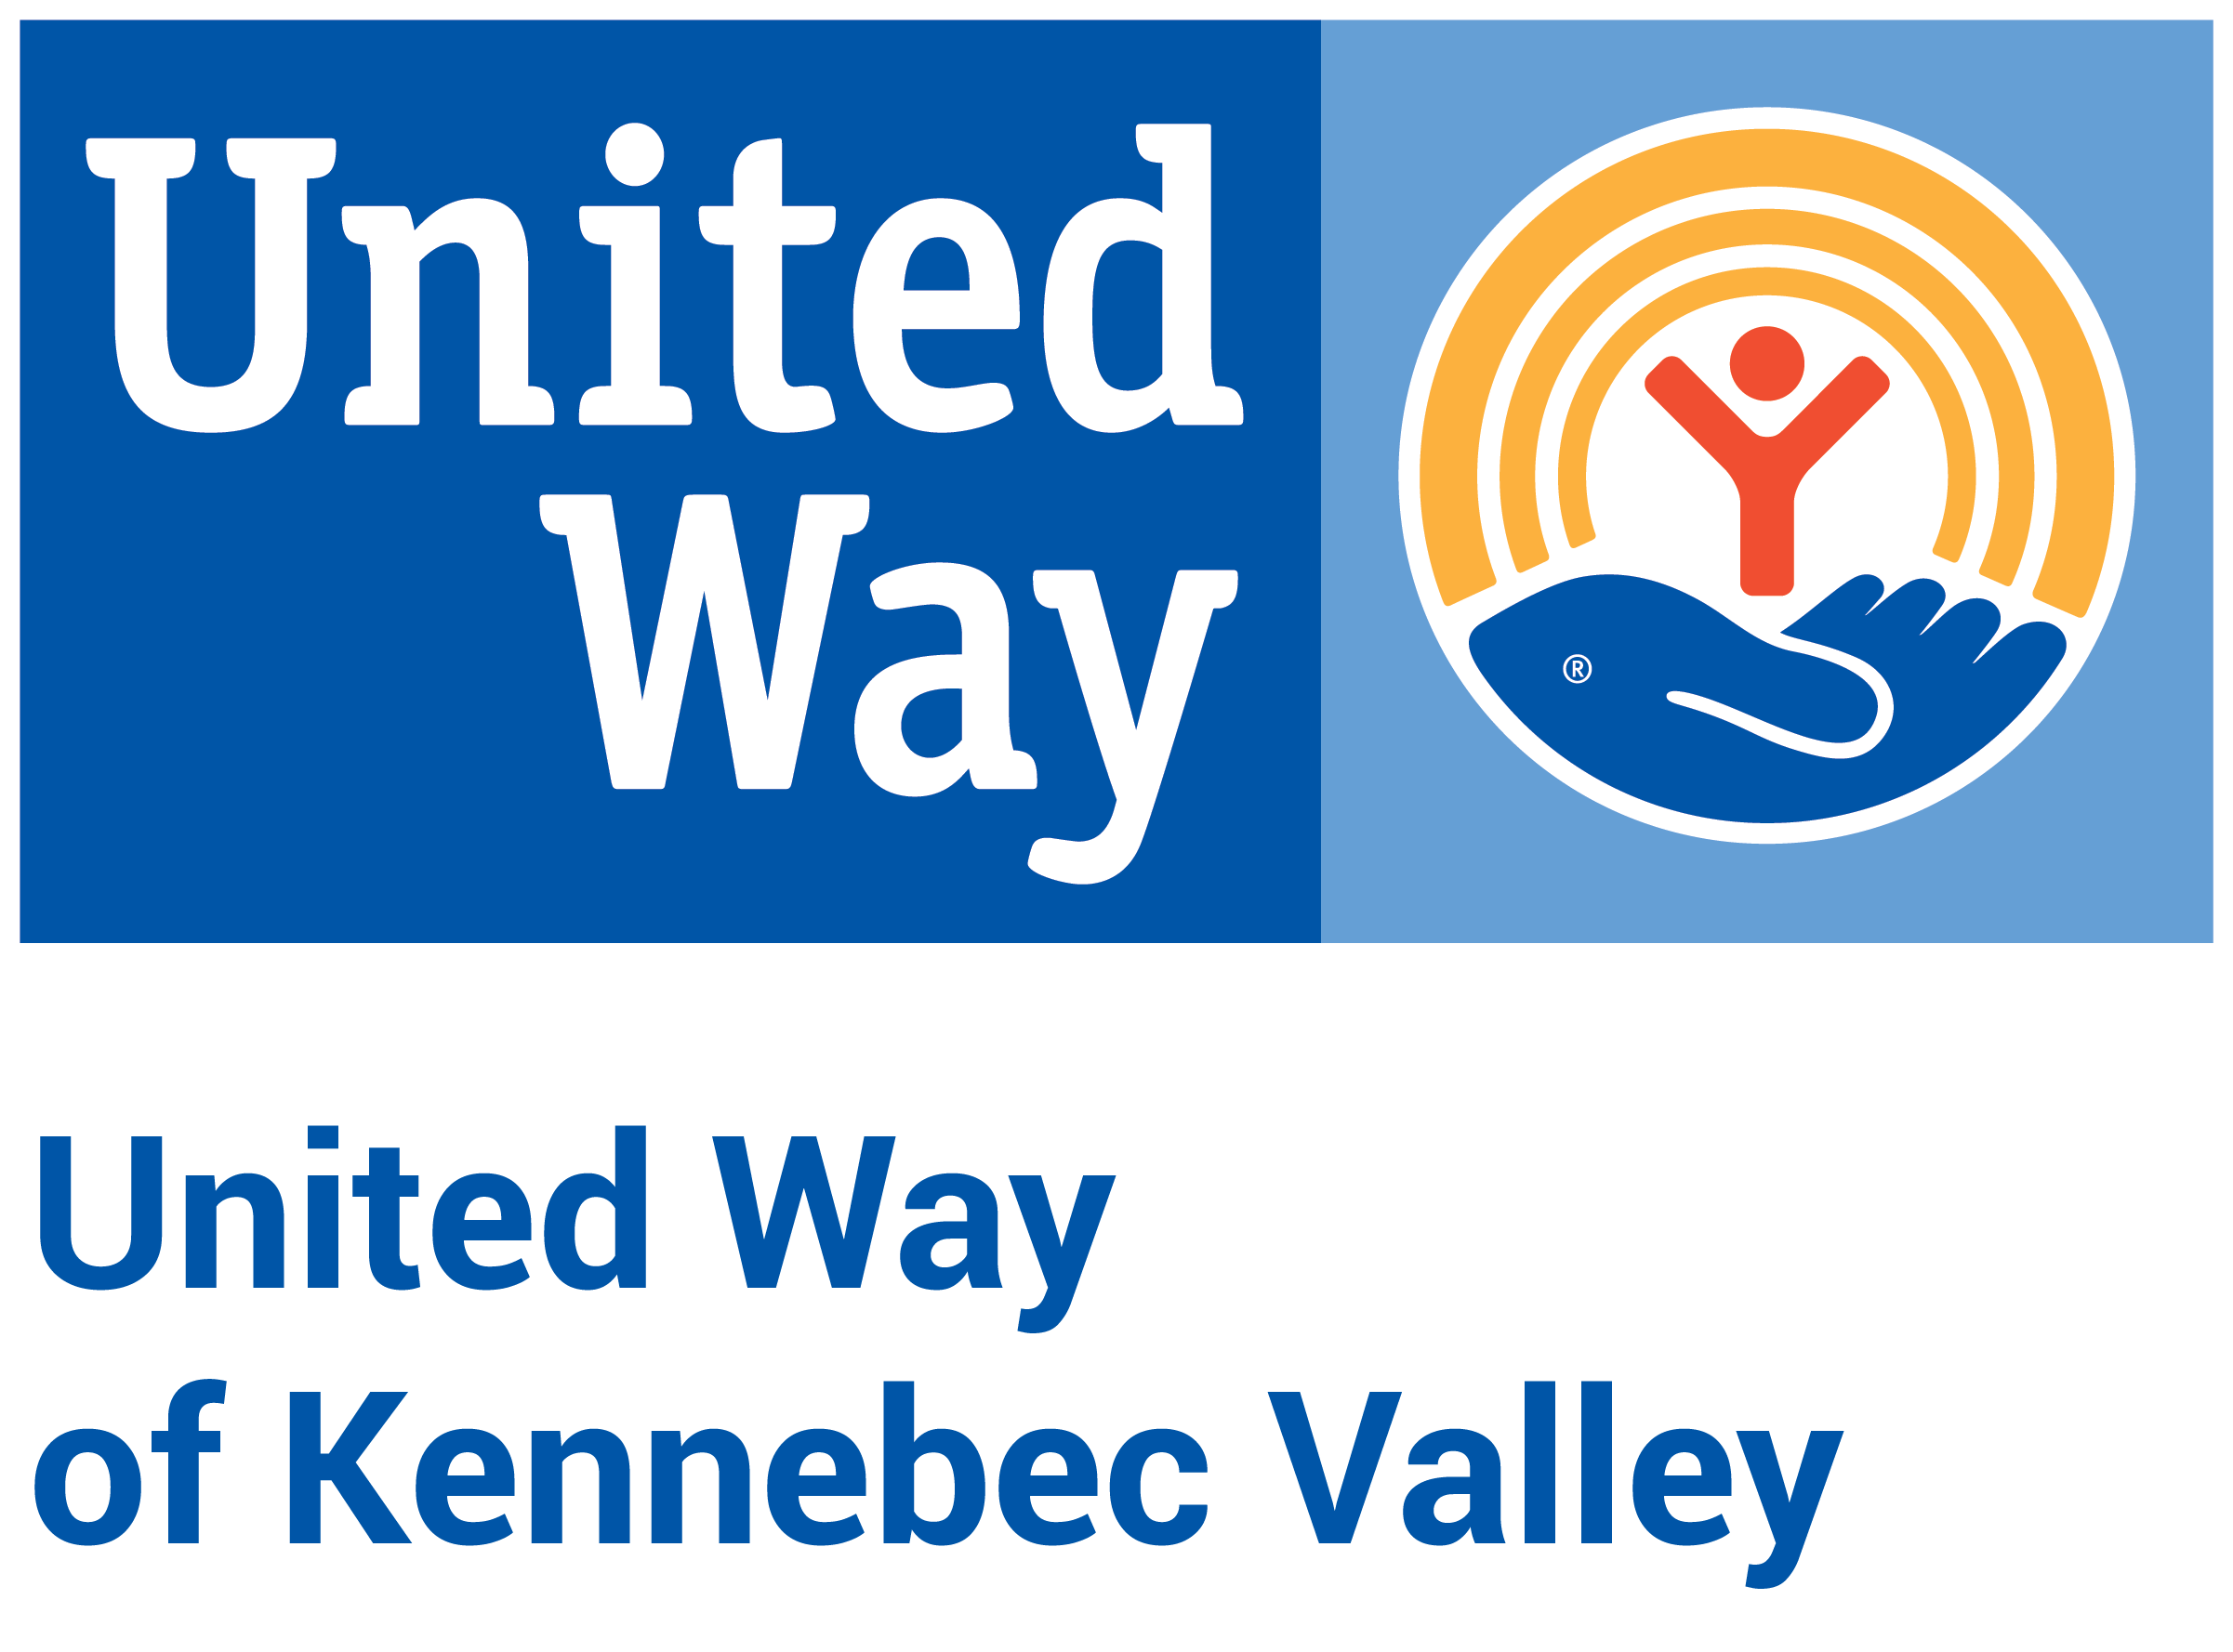

United Way of Kennebec Valley
2025 Community Investment Process – Letter of Intent
Funding Period: May 2025 – March 2027
Letter of Intent Due Date: November 8, 2024, at 4:00pm

Instructions

Use this template, if desired, to draft your Letter of Intent application before entering it into the e-CImpact grant management platform. You cannot submit your Letter of Intent as a Word document or PDF.

“Comments” on this document have been intentionally included to help you understand our expectations and delineate which questions are required for each funding stream.

We include character counts to help you understand the length of response we’re looking for; character counts include spaces. If you are applying for the Basic Needs Grant, we don’t expect the same level of detail and length of response as we do for the other two applications.

United Way of Kennebec Valley (UWKV) is accepting Letters of Intent to address Impact2032 goals in health, education and financial stability in Kennebec County until November 8, 2024, at 4:00pm. Programs that are selected to move onto the second and final phase, the Application for Funding, will be notified by November 27, with the Application for Funding opening on December 2.

Our expectation is that programs will expend funds during the Funding Period (May 2025-March 2026 and April 2026-March 2027) and report data back based on that Funding Period.

Note for Programs: This application is for two years of funding at the same amount. (Example: If you hope to receive $15,000 in 2025 and $15,000 in 2026, please apply for $15,000 total. Do not apply for $30,000.)

Link to e-CImpact application: https://agency.e-cimpact.com/login.aspx?org=21010

Choose Your Grants Process

During this phase of the process, and new this application season, programs must elect to apply for one of three funding streams within the Community Investment Process:

- Strategic Investment Grants
  - UWKV’s Strategic Investment Grants serve as the primary vehicle for funding existing programs that align with our Impact2032 county-wide vision. These grants play a pivotal role in driving positive changes in the lives of 1 in 3 individuals across Kennebec County. With a commitment to transparency, community involvement, diversity and inclusion, and strategic alignment and advancement, these grants empower organizations to address pressing issues, choose shared community measures, and contribute to the vision of Impact2032. Grants range from $10,000-$50,000. This grant process is most similar to our recent 2023-2025 process.
- Basic Needs Grants
  - The introduction of Basic Needs Grants streamlines the application process, encouraging participation from a broad range of organizations to collectively support Impact2032 and build a stronger and more resilient community. If you are applying for the Basic Needs Grant, we don’t expect the same level of detail and length of response as we do for the other two applications. Grants range from $2,500-$10,000.
- Innovation Grants
  - UWKV is folding its former Innovation Fund into the Community Investment Process to regularly foster innovation in the social sector. UWKV defines an “innovative” approach as a novel solution that is more effective, efficient, collaborative, and/or sustainable than current solution(s). Applicants should seek to experiment, pilot, or test new ideas and approaches that can help further the Impact2032 vision. Must use UWKV funding to develop a new approach and/or program that the organization does not currently have. Grants range from $5,000-$30,000.

Letter of Intent Application Questions

At different points in the application, you will be required to verify that you meet the Eligibility Requirements.

Organization & Contact Information

- Type of Applicant (choose one from a dropdown):
  - Nonprofit 501(c)(3)
  - Public school district
  - Municipal entity
  - Indian Tribal government

- Does the applicant have a fiscal agent?
  - Yes
    - If YES, the following questions will pop up:
      - Fiscal Agent Name (This is the holder of the 501(c)(3) Federal Tax ID or EIN):
      - Fiscal Agent Tax ID or EIN:
      - Fiscal Agent Address:
      - Fiscal Agent Website:
  - No

- Organization Name:

- Tax ID or EIN:

- Year of Organization’s Incorporation:

- Organization Website:

- Primary Address:

- Does your organization have a separate mailing address?

- CEO/Executive Director
  - Contact Information (name, title, phone, email)
- Board Chair
  - Contact Information (name, phone, email)
- Volunteer Coordinator
  - Contact Information (name, phone, email)
- UWKV Employee Campaign Manager
  - Contact Information (name, phone, email)
- Organization Administrative & Fundraising Costs (%)
- Organization Mission (400 characters)

- Organization Description (750 characters)
- Is your organization collecting demographics information for your board? Yes/No
  - If Yes
    - Please share a summary of aggregate demographic data for your board (e.g., race/ethnicity, gender identity, disability/ability status).
- Is your organization collecting demographics information for your staff? Yes/No
  - If Yes
    - Please share a summary of aggregate demographic data for your staff (e.g., race/ethnicity, gender identity, disability/ability status).

- Describe how your organization strives to promote diversity, equity and inclusion among staff, board, volunteers, and users of your services. What specific actions have you taken to identify and/or address disparities and/or promote DEI? (750 characters)

- Does your organization have any legal processes pending? Yes/No
If so, please explain. (750 characters)
- How many program applications are you submitting to UWKV in this funding cycle?

- Organizational Budget Information (Note: You do not need to submit any budget-related attachments for the LOI Application.)
  - Organization’s Total Annual Budget: $

Note: After you have completed the Organization & Contact Information section, you will need to “Create a New Program and Assign it to this Form Packet.” This link is under the right-hand box titled “Assign Programs to this Letter of Intent.” If you would like to apply for funding for more than one program, you may add more than one program to your organization’s application.

Program Registration

- Program Name:

- Program Primary Contact (name, title, email, phone):

- Address (with option to copy Organization Primary Address):

- Email Address:

- Phone Number:

Note: Once you have submitted the Program Registration, two additional sections will show up in the box at the bottom of the page: Program Information and Budget Narrative Information.

Program Information
- Which of the three funding streams within the Community Investment Process is your program applying for:
  - Strategic Investment Grant
  - Basic Needs Grant
  - Innovation Grant
- Program Name for which funding is being requested: Auto-fills from program registration page
- Program Description: Provide a brief description of the program for which you are requesting funding. (750 characters)
- What is the need for this program in the community? (1250 characters)
- How is your proposed program/project innovative for our community? (1250 characters)

- Is this an application for a Collaboration? (A collaboration is a formal partnership among 2 or more organizations working together to provide a program. If you list a Collaboration organization, you will need to provide an MOU in the next phase of the process. In addition, all Collaboration organizations must have an Impact2032 Statement of Endorsement on file at UWKV.)
  - Yes
    - If YES, includes these questions:
      - Collaboration Name:
      - Collaboration Website, if available:
      - Number and list of organizational partners:
      - Collaboration Description (750 characters):
  - No

Strategies and Measures Preview (within Program Information section—not the official Strategies and Measures section)

Please review the Impact2032 Vision framework in detail before completing the following section. While the mission of your organization and/or purpose of your program may not be directly related to the goals of Impact2032, please consider the vision statements and desired outcomes in the design and delivery of your program in order to further the progress of Impact2032.
- Please select which Impact2032 Vision Statement your program will best contribute to achieving, based on each vision’s desired outcomes, measurements and strategies. (Choose which one best fits.)

  - Vision for Health - Children and adults in Kennebec County will have opportunities to engage in healthy behaviors and leverage prevention and wellness services.
  - Vision for Education - Children and families in Kennebec County will have access to quality early learning experiences prior to kindergarten.
  - Vision for Financial Stability - Adults and families in Kennebec County will have employment, income and resources to achieve ﬁnancial stability.

- Provide an overview of how you plan to align with Impact2032 through this program. How will you consider your chosen vision statement in the design and delivery of your program in order to further the progress of Impact2032? (750 characters) Note: If your Letter of Intent is approved for a Strategic Investment Grant or Innovation Fund Grant, your program will be required to provide more detailed information within the full Application for Funding. For the full Application, this detailed information will include how the program supports 1-3 outcomes, 1-2 strategies per selected outcome (from the Key Strategies list or of your own choosing), and 1-2 measures (from Measures list) per provided strategies. For this question in the LOI, each program only needs to provide an overview of Impact2032 alignment under your selected Vision Statement.

Demographics Served

- How many unique individuals (unduplicated) do you anticipate your program will serve with UWKV funding? Reminder: Applicants must use funding to serve residents of Kennebec County or those who are unhoused exclusively. This number should include only the number of people that UWKV funding specifically would help, which may differ from total number of people served through the program.
  - Insert number

Budget Narrative Information
- Funding Amount Requested for the Program (Reminder: Each grant type has its own funding ranges; please answer accordingly.): $
- Total Program Budget (Reminder: Your funding request cannot exceed 35% of the program/project budget.): $
- In a few sentences, please describe how you plan to use the funds being requested from UWKV. (Note: Do not include individual budget line amounts.) (750 characters)

